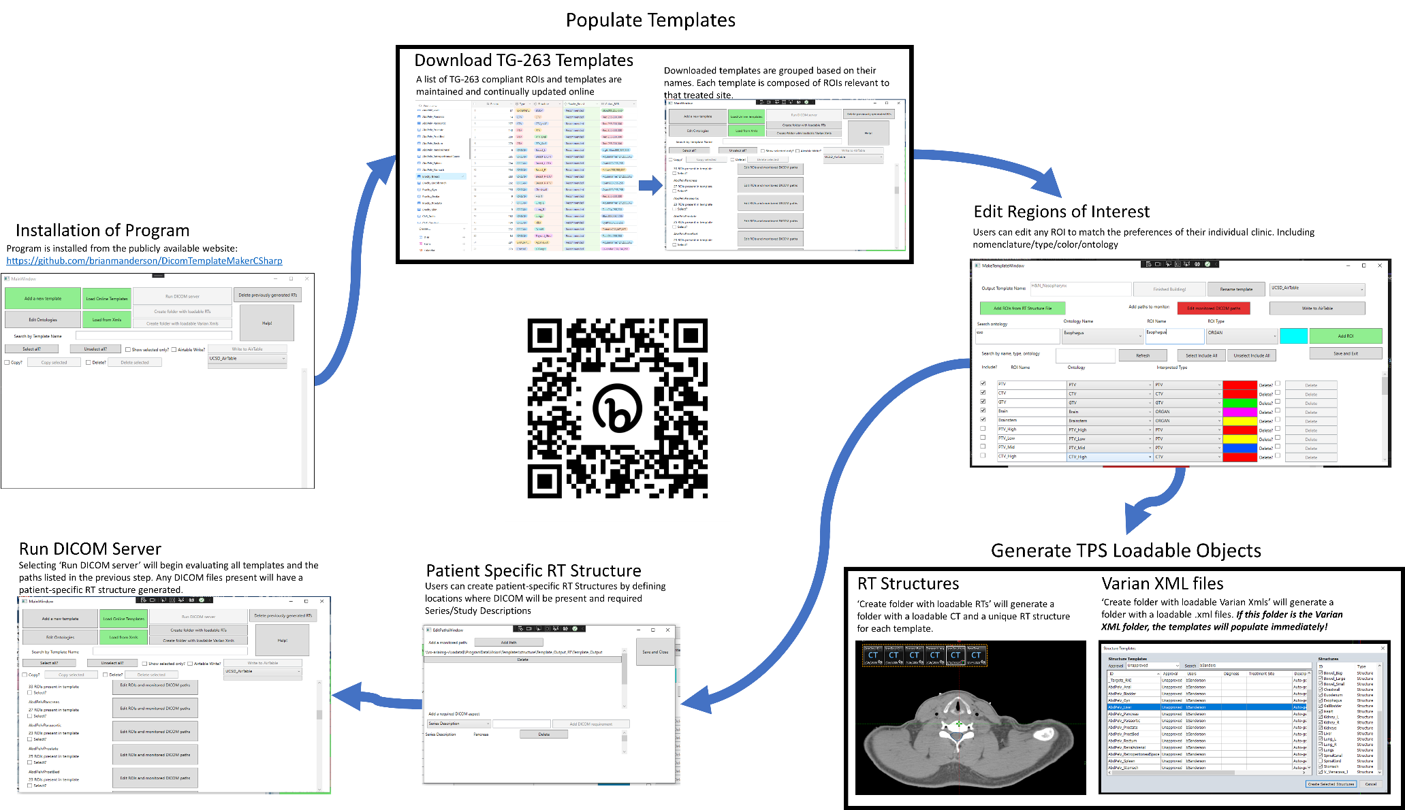

Figure : Workflow of the program with images captured during use.